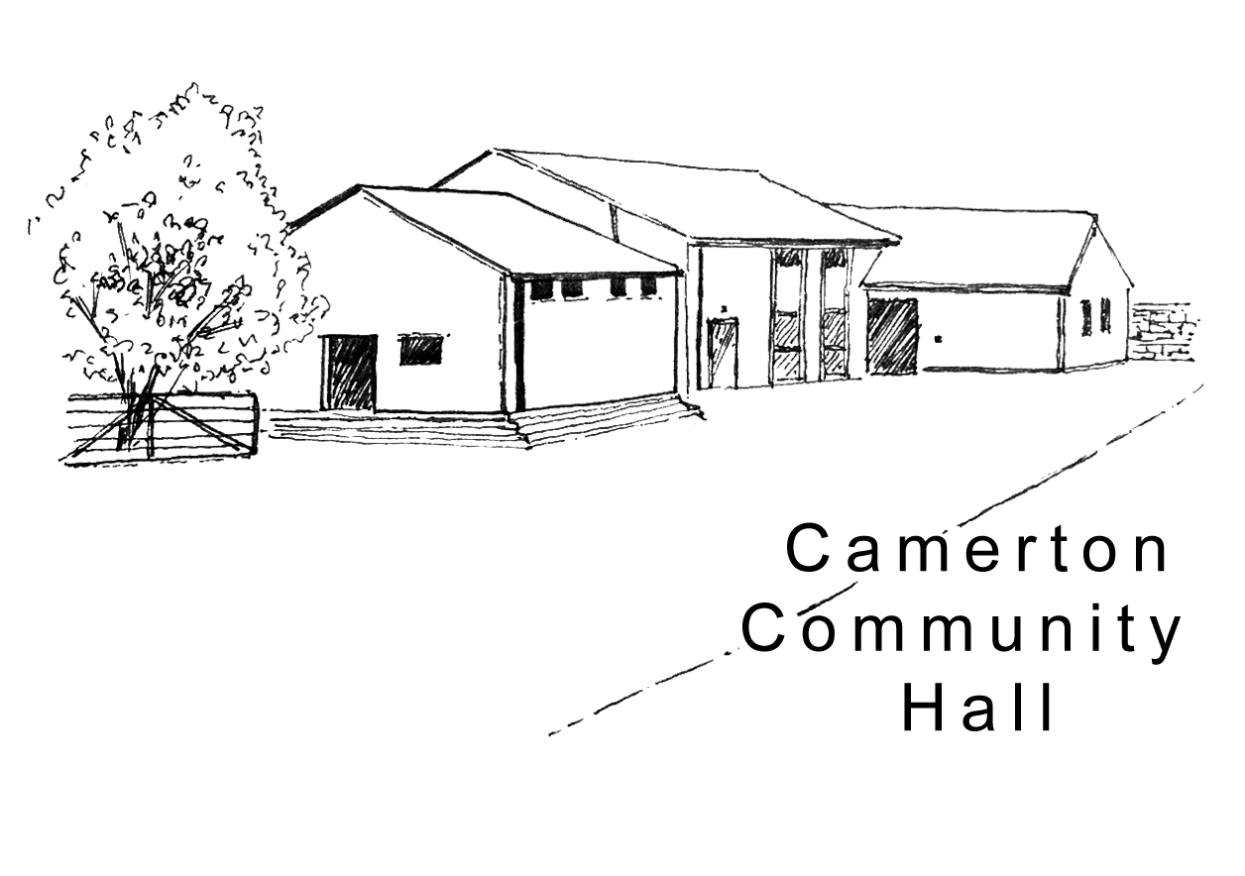
Camerton Community Hall
Complaints & Compliments Policy

Complaints & Compliments Officer: CCH Secretary (Voluntary)
_____________________________________________

Introduction
Camerton Community Hall Management Committee is committed to providing our users and hirers with the best service possible in line with the objects stated in our Articles of Association. However, we know that there may be times when we do not meet our own high standards. When this does happen, we want to hear about it, deal with the situation as quickly as possible and put measures in place to stop it happening again. We take complaints very seriously and see them as an opportunity to help us see where our services or procedures might be improved. They also give us the chance to put things right for the person or organisation that has made the complaint.

Our policy is:
- To publicise the existence of our complaints procedures so that people know how to contact us to make a complaint or a compliment
- To provide a fair complaints procedure which is clear and easy to use for anyone wishing to make a complaint
- To make sure that all members of the Camerton Community Hall Management Committee know what to do if a complaint is received
- To make sure all complaints are investigated fairly and in a timely way
- To listen and discuss your expected outcomes
- To make sure that complaints are, wherever possible, resolved fully and that relationships are repaired
- To gather information to help us to improve what we do and the services that we provide

Definition of a Complaint
Camerton Community Hall defines a complaint as “an expression of discontent by a person or persons receiving a service from the charity that cannot be immediately resolved at point of delivery, and about which the complainant desires a follow-up action is taken and a response provided”. Complaints may come from any person or organisation that has a legitimate interest in Camerton Community Hall through use of the Hall buildings, its services and/or the Recreation Field.

Confidentiality
All complaint information will be handled sensitively, advising only those who need to know and following any relevant data protection requirements.

Responsibility
Overall responsibility for this Policy and its implementation lies with the Board of Trustees of the Camerton Community Hall Management Committee.

How to Complain
Step 1: Contacting us
Our aim is to resolve issues quickly so that they do not escalate into a complaint. The first step, therefore, should you encounter a problem, is to approach the Camerton Community Hall representative initially responsible for the issue. Hopefully, they are in a position to resolve the problem swiftly and will do so if it is possible and appropriate. Alternatively, you are welcome to complete the Complaints Form attached.

Regardless of the outcome of this initial contact, the information will be passed on to the Secretary to be registered in the Complaints Log.
Should you feel that your issue has not been resolved and wish, at this stage, to register your complaint in writing, you can send an email to the Secretary at cchallsecretary@gmail.com
Your complaint will be acknowledged as soon as possible but will normally be within three working days although it could take longer. If the complaint relates to a specific person, they will be informed and given a fair opportunity to respond.
Ideally complainants will receive a definitive reply within four weeks if not sooner. If this is not possible because for example, an investigation has not been fully completed, a progress report will be sent with an indication of when a full reply will be given. The reply will describe the action taken to investigate the complaint, the conclusions from the investigation, and any action taken/outstanding as a result of the complaint. In light of a complaint on either side following a hire, Camerton Community Hall Management Committee reserve the right to withhold the Damage Deposit Bond until the issue is concluded and agreement reached.

Step 2: Taking your complaint further
We hope that you feel that your complaint has been properly dealt with in step 1; however, if you are still unhappy, it is important that you let us know so that we can take it further. You can request your complaint to be passed to the Chair of the Board of Trustees of Camerton Community Hall Management Committee who will arrange for it to be fully investigated and will respond directly back to you with the outcome of the investigation. This will normally be within five working days although it could take longer.

It must be noted that matters regarding individuals and any specific action taken as a result of a complaint against an individual will not be discussed either formally or informally with any person raising the complaint owing to possible breach of confidentiality.

Step 3: Complaint to the Charity Commission
There is an option to complain to the Charity Commission at any stage. Information about the kind of complaints the Commission can involve itself in can be found on their website at: www.charitycommission.gov.uk/publications/cc47.aspx

Variation of the Complaints Procedure
The Board of Trustees may vary the procedure for good reason, for example, to avoid a conflict of interest.

Monitoring and Learning from Complaints
In line with data protection, all complaints are reviewed on a regular basis by the Board of Trustees to identify any trends, which may indicate a need to take further action.

Compliments
Camerton Community Hall Management Committee welcomes compliments and positive feedback to confirm we are doing things right.

If you would like to give positive feedback, please submit the attached Compliment Form to cchallsecretary@gmail.com or a hall representative.

Review
This policy is reviewed annually, made available on our website at www.camertoncommunityhall.co.uk and updated when required.

Camerton Community Hall Management Committee

Camerton Community Hall

Complaint Form

Date of complaint

Name, address, email and telephone number/s

Nature of complaint
Complaint information

Signature and date to
Confirm the above/ is an accurate record
Desired outcome/s of the complaint

For Hall Use:
Date complaint received
Actions required
Date complaint resolved

Signed by Chair of Camerton Community Hall

Camerton Community Hall

Compliment Feedback Form

Date: | Name:
Contact number/s

Email Address

Address

Nature of Compliment

Feedback

Signed:

