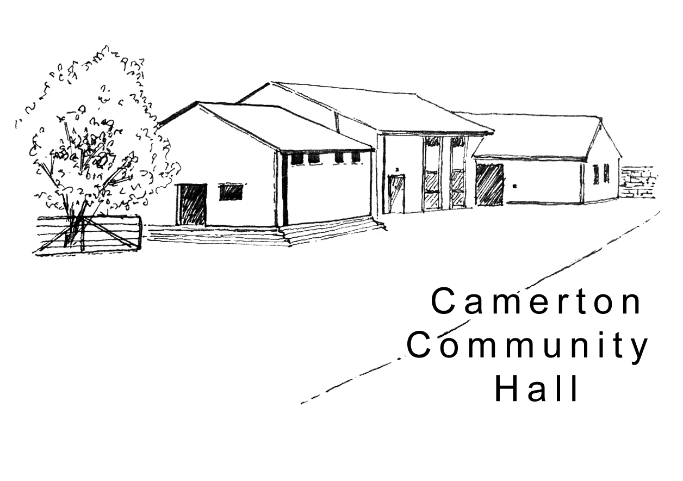

Camerton Community Hall
Registered Charity No. 308263
Single Use Hire Contract 2024/25

- DAY / DATE / TIMES OF HIRE REQUIRED

Day | Date Required | Hall Hire Period  (To include setting up & clearing) |  | Hours | Times Resident Bar Service Required @ £50.00
 |  | Start: | End: | Total | From: | To:

- PURPOSE OF HIRE
Approx. No. attending (200 max)

- HIRER'S DETAILS

Organisation (if applicable): ..................................................................................................................................

Hirer/Name of overall Responsible Person present at end of hire: ..............................................................................

Address: .......................................................................................................................................................................

……………………………………………………………………………………….…Post Code ……….…………….……..

Personal Tel: ........................................................................Business Tel: …………….…......…………………..…..…

Email: .....................................................................................................................................................
(We ask for your email address to enable communication directly with you. We do not share or make public your personal details)

- HALL HIRE CHARGES

Facilities/Period of Hire | No. of Hours / Sessions Required | Hire Charge | Sub Total £
Hourly Rate  (Except, Fri 6pm-12 midnight + Sat as below)  Note: Use of field – price on application |  | £15.00
Fri 6pm-12 midnight |  | £100
Saturday 8am-midnight  Saturday 6pm-midnight |  | £300.00  £175.00
Gas/Electric Ovens, per 4 hour session |  | £25.00
Resident Bar Service |  | £50.00

2

5. DISCOUNTS (Please complete where applicable):

Residents of Camerton | 10% Discount | Less £
Friends (*Conditions apply)  *To qualify for the 50% discount a “Friend” needs to have completed 20 hours of volunteering prior to the booking date.  The Booking is only for the “Friend” and does not apply to family members or friends of “Friends”. | 50% Discount | Less £

6. PAYMENTS DUE

Total Cost (less discount if applicable) | £
50% of Total Cost (Non-Returnable payment payable immediately to secure booking) | £
Installments will be made by: BACS (Preferred) [ ] Cheque [ ] CASH [ ]

- BACS to Camerton Community Hall - Nat West, Sort Code: 60-14-24 Account Number: 32474628
- Use Payment Reference - Hirer’s name & date of hire (e.g. JSmith 030617)
- OR Cheque payable to ‘Camerton Community Hall’ and sent to address below

Final Payment (due 6 weeks prior to the date of actual hire) |  | £

7. DAMAGE/MISUSE/CLEANING DEPOSIT
(Refunded within 10 working days following your event, providing all T&Cs are met)

Damage/Misuse/Cleaning Deposit (DMCD):  - Hourly Bookings per event - £50  - Saturday/Evening Events - £150  - 21st Parties (strictly no 18th parties allowed) - £300  - Camping/Other Special Events – Price on Application  Payable 6 weeks PRIOR to actual date of hire as a separate payment | £
NOTE: Payment details for a separate ‘Deposits Only’ account, will be sent to you when due (6 weeks prior)

8. INSURANCE
It is advisable to have your own insurance cover if you are having a bouncy castle or similar equipment (with permission from management committee).

9. SAFEGUARDING POLICY

a) Policy

Camerton Community Hall is committed to safeguarding and promoting the welfare of children, young people and vulnerable adults and expects all hirers, trustees, members and volunteers to share this commitment.

b) Events for under 21s

If you are organising an event for Under 21 years, please complete the full contact details of two additional adults.

RESPONSIBLE ADULT SUPERVISOR (21 or over) No. 2:

Name ..........................................................................................

Home Address: .......................................................................................................................................

…………………………………………………………Phone: .....................................................................

RESPONSIBLE ADULT SUPERVISOR (21 or over) No. 3:

Name ................................................................................................

Home Address: ........................................................................................................................................

…………………………………………………………Phone: ......................................................................

DECLARATION

I confirm that I am over 18 and that I have read, understood and agree to observe and abide by the Terms & Conditions of Hire (www.camertoncommunityhall.co.uk/rentals) and the attached Appendix –
Hirer’s Responsibilities - 10 Essentials:

I will be personally responsible for the safe conduct of this event and the activities that take place in association with the booking/period of hire:

I have appropriate insurance and first aid cover (if required) and accept Camerton Community Hall’s commitment to the safeguarding of vulnerable groups:

Signed by Hirer: ........................................................... Date: ......................................................

Print Name: ..................................................................

TO SECURE BOOKING YOU NEED TO:

- Complete Booking Form
- Pay deposit of 50% of Booking Charge by BACS (email Treasurer to confirm you have paid) or by cheque

Return booking form, cheque and cash payments to:

Maggie Hutton, CCHT, Long Acre, Durcott Lane, Camerton, BA2 0QE cchtreasurer@outlook.com

You will receive confirmation of booking by email once all paperwork and initial payments have been received.

Thank you.
We hope you enjoy using our facilities and have a successful event

Camerton Community Hall, Meadgate, Camerton, Bath BA2 0NL
Registered Charity No. 308263
www.camertoncommunityhall.co.uk
January 2023

Appendix

Camerton Community Hall

The Camerton Community Hall Management Committee manages the Hall and its grounds. Hirers must look after the facilities, collect and leave keys as required and leave the venue in a clean and tidy condition.

Failure to comply with any of your contractual responsibilities listed below could result in some or all of your Damage/Misuse/Cleaning Deposit being withheld.

HIRERS RESPONSIBLITIES - 10 Essentials

- Maximum number of people must not exceed 200. The Hirer is responsible for the Hall during the hire period and must be always present and responsible for the event.

- Insuring his/her own activities. Events involving young people under the age of 21 must be supervised by a minimum of three adults aged 21 and over.

- It is a residential area – please keep noise down and to an absolute minimum outside of the hall, especially late at night, including in-car music, shouting, screaming and rowdy behaviour. YOU will be held responsible for your guests’ conduct in or around the hall.

- No alcohol to be personally brought onto the premises where a bar under licence has been booked.

- You must familiarise yourself with Fire Exits and foam/dry fire extinguishers. Fire Exits/corridors must not be obstructed at any time. Battery operated candles ONLY to be used on the premises.

- NO DOGS ALLOWED – on any of the hall property including the field, car park and Copse areas, unless authorised.

- No pins, staples, adhesive etc. to be attached to the fabric of the hall. Blu-Tack can be used and hooks are provided. No extra lighting, extensions, heating appliances or other electrical equipment must be used without prior consent of the Committee.

- As stipulated by the local authority, A NOISE LIMITER governing device will cut out electric in the event of extreme levels of sound. Please bring this TO THE ATTENTION OF the Band, DJ or entertainment.

- The Hall, kitchen and bar areas to be left in a clean and clear state. ONLY non-abrasive cleaning materials to be used. The hirer must NOT attempt repair work.

- You must bring your own black bin bags and ALL rubbish and recycling MUST be taken away from the hall premises/grounds on leaving so as not to affect the return of your full Damage/Misuse/Cleaning Deposit. The Hirer is responsible for vacating everyone and everything from the Hall by the time stated, ensuring all equipment is turned off and doors/windows locked. Please remove all rubbish and effects.

Full Responsibilities are detailed in the Hall’s Terms and Conditions of Hire at www.camertoncommunityhall.co.uk

April 2022

