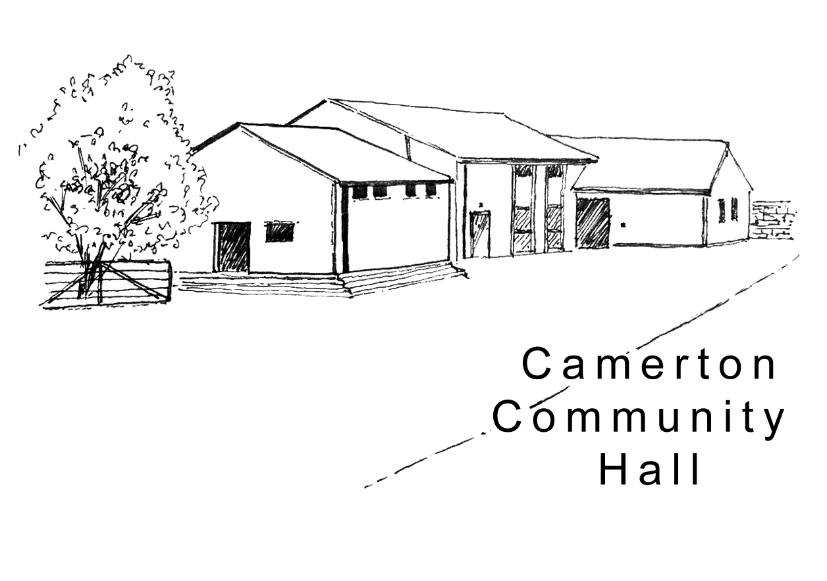
Camerton Community Hall
Registered Charity No. 308263

Wedding/Event Single Camping Unit Pitch Rental 2026/27
Designed for individual guests to complete and return DIRECT to the Treasurer with full payment.

1. EVENT DETAILS
Name of Event: |  | Date of Event:

2. UNIT/TENT OWNER
Name of Responsible Person
Address
Email
Landline |  | Mobile

3. DATE /TIME OF PITCH HIRE
Date of Arrival | Date of Departure

4. PITCH HIRE CHARGE
Facility | Booking Charge | Total
SINGLE PITCH | £30 per unit/Tent per night (Maximum of 2 nights)
Electric Hook up - commercial | £20 per session
Electric Hook up – camping | £5 per unit per night
Electric hook up - car | Price on application

Rental Payment will be made by: BACS (Preferred) [ ] Cheque [ ] CASH [ ]

5. PAYMENT TERMS
- Full Payment due with completed booking form in advance
- BACS payment to Camerton Community Hall (Somerset), Sort Code: 60-14-24 Account Number: 32474628
- Cheque/s payable to Camerton Community Hall posted to address below
- Payment Reference – Pitch Rental’s name/responsible person, date of event
6. SAFEGUARDING
Camerton Community Hall is committed to safeguarding and promoting the welfare of children, young people and vulnerable adults and expects all hirers, trustees, members and volunteers to share this commitment.
7. NO DOGS ALLOWED: on hall property, including the recreation field, car park and Copse areas
8. NOISE: It is a residential area – please keep noise down to an absolute minimum outside, especially late at night.
9. All rubbish and recycling to be taken home with you

DECLARATION
I confirm that I am over 18 and that I have read, understood, and agree to observe and abide by the Terms and Conditions of Rental of the Hall and Recreation Field and will be personally responsible for the safe conduct of my party and the activities that take place during our stay.

Signed: .......................................... Print Name: ............................................ Date: ...................................
To secure booking: Complete form and return with full payment. PLEASE NOTE: If full payment for your camping is not received prior to the event, then you will not be allowed to pitch your tent/unit overnight.

Return to: Maggie Hutton, Treasurer, Longacre, Durcott Lane, Camerton, BA2 0QE, cchtreasurer@outlook.com

Thank you. We hope you enjoy using our facilities and have a great stay – Please leave no rubbish
Camerton Community Hall, Meadgate, Camerton, Bath BA2 0NL
www.camertoncommunityhall.co.uk

