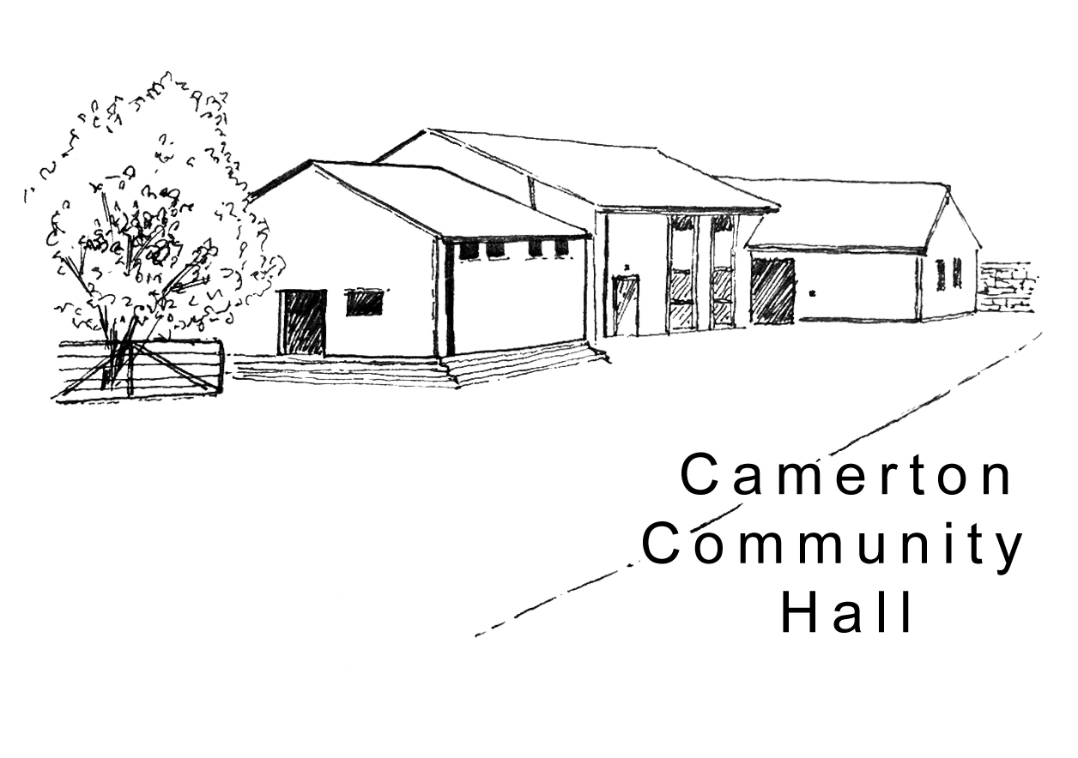
Camerton Community Hall

Terms & Conditions of Hire

Please read and understand these Terms & Conditions of Hire before making your booking. The Hire Contract ‘Declaration’ confirms that you have read, understood and agree to observe and abide by the Hall’s Code of Conduct (see www.camertoncommunityhall.co.uk/rental). A copy of this information should be retained for your event and the information shared with key responsible persons.

The Camerton Community Hall Management Committee manages Camerton Community Hall and its grounds. Hirers are expected to look after the facilities, collect and leave keys as required and leave the venue in a clean and tidy condition. The Hall is in a residential area and all users should respect this by keeping noise levels to a reasonable level and at an absolute minimum when outside during the event or leaving late at night.

Terms Used: Committee – Camerton Community Hall Management Committee or representative. Hall – all property and facilities offered by Camerton Community Hall. Hirer – Individual hirer or where the hirer is an organisation, the authorised representative.

1. General
- The maximum number of people allowed at any event at the Hall must not exceed 200 (including performers and/or helpers)
- All children under the age of 14, present inside the hall must be accompanied at all times by a responsible adult.
- Full payment must be made to confirm your booking. This is not refundable on cancellation unless the Hall is re-let or conditions of the hire are not met.
- The Hirer will not allow the consumption of alcohol that has been personally brought onto the premises where a licenced bar has been booked. Alcohol must only be given to or purchased by guests from the bar under license.
- The committee reserves the right to refuse any booking without explanation or cancel a hire agreement giving 7 days notice in writing. Upon such notice the Hirer shall be entitled to reimbursement of any monies paid to the Committee. The Committee will not be liable for any further payments or for any loss or damage or other costs incurred whatsoever.
- In the unlikely event of the Hall being rendered unfit for the use for which it has been hired, the Committee shall not be liable for any resulting loss or damage whatsoever.
- The Committee reserve the right to change all or any part of the T&Cs at any time at their discretion.
- The Hall provides a Music License on behalf of its users.
- To comply with Phonographic Performance Limited PPL is the responsibility of the Hirer to obtain a music license for use of all recorded music played in public such as CDs, tapes, videos or DVDs.
- No pay phone is available. The best mobile signal is out in the car park.

2. Legislation
- The Hirer shall indemnify the Committee against any third-party claim, which may lie against him/her whilst using the hall. The Committee is insured against any claim arising out of its own negligence
- The Hirer is responsible for insuring his/her own activities against any third-party claim. (A representative of the Committee may request a copy)
- A Hirer cannot sub-let the hall to another person/organisation.
- The Hirer must not allow the Hall to be used for any unlawful purpose or in any unlawful way that may render invalid any insurance policy or bring the Hall into disrepute. Please refer to the Premises Licence displayed in the foyer.
- NO SMOKING is permitted anywhere within the main building. A designated outside area with smoking bin is provided to the left-hand side of the main entrance.
- The Hirer shall, if preparing, serving or selling food, observe all relevant Food, Health & Hygiene regulations. For further information please see: www.bathnes.gov.uk/services/environment/food-safety/catering-events or www.food.gov.uk/business-industry/food-hygiene. A notice advising of any allergens should be displayed.
- Events involving young people under the age of 21 must be supervised by a minimum of three adults 21 and over.

3. Fire Safety
- The Hirer is responsible for nominating a competent person/s to act as Fire Officer and take the lead in the event of fire. The Fire Officer/s should familiarise themselves with all Fire Exits and foam or dry fire extinguishers available. Improper use of Fire Safety Equipment will result in an additional cost.
- Notices in the Hall indicate the location of the Fire Assembly Point outside the Hall behind the toilet block near Bench. The Fire Service must be called to EVERY fire immediately, no matter how slight.
- Fire Exits/corridors must not be obstructed at any time.
- Bringing fireworks or the ignition of fireworks at the Hall is forbidden unless requested and approved at the time of booking. Evidence of competence to use will be required by the Committee.
- Candles/tea lights or naked flames are not permitted anywhere in the hall buildings. Battery operated ones ONLY.

4. Health & Safety
- Camping or use of a Bouncy Castle (insurance cover required) may be allowed at the discretion of the Committee but a request must be made prior to booking.

2

- NO DOGS ALLOWED POLICY – on hall property including the field, car park and copse areas unless authorised.
- All glasses to be of toughened safety glass to prevent accidents or injury and no spirits stored on the premises.

5. Prior to Event
- Instructions with regard to the collection and return of keys will be given.
- Hirer to ensure that no fixtures and fittings are fixed to any part of the Hall that might cause damage, i.e. pins, staples or adhesive tape to the walls or paintwork. Blu-Tack can be used. No flags, emblems or other to be displayed outside any part of the Hall without prior consent.

6. During Event
- The Hirer is responsible for any damage or loss to the Hall during the hire period and must be present and responsible for the event at all times.
- The Hirer is responsible for the behaviour of all persons using the premises, including proper supervision of the outside area to minimise noise or behaviour likely to disturb local residents.
- The Committee will not tolerate any behaviour that is not respectful of others. The Hirer should ask those exhibiting such behaviour to leave the event calmly. Failure to do so could result in the event being closed with immediate effect.
- The Hirer must observe the noise level in the Hall and outside to conform to the Local Authority regulations. This applies to ANY noise outside including in-car music systems, shouting, screaming, rowdy behaviour etc.
- A NOISE LIMITER sound level governing device installed will cut out the electric to stop any extreme high levels of music as stipulated by the local authority. Please bring this TO THE ATTENTION OF the Band, DJ or entertainment. Should noise levels be at an unacceptable level, this will be activated. It cannot be reset and no attempt to by-pass the device will be tolerated.
- Extra lighting, light extensions, heating appliances or other electrical equipment must not be used without prior consent of the Committee and if allowed must have a safety check and used in a safe manner.
- Hirer or a representative should record any accident/incident or any first aid items used in the Accident Book provided in the First Aid Box in the kitchen.
- The Committee cannot, under any circumstances, accept responsibility for injury sustained by any person nor for the loss of or damage to personal items including vehicles/contents left in the car park.
- The Hirer agrees to take steps to comply with the relevant sections of the Children’s Act 1989 with adequate adult to child supervision.

7. Following Event
- The Hall should be left as found in a clean and tidy state ready for the next hirer. Should it be left unsatisfactory or there is loss or damage, the additional Damage Deposit could be partially or wholly forfeited. In extreme cases, any substantial extra costs incurred as a result such as cleaning, re-set of Noise Limiter, repairs or loss/damage replacement will be charged to the Hirer. The hirer must NOT attempt repair work.
- The Hirer will notify the Committee of any occurring accident, damage or breakage. The Committee will carry out all rectifications at the full cost of the Hirer.
- Kitchen and Bar Area - to be left in good order with all work surfaces clean and clear, kitchen appliances and equipment returned to where found and the floor swept and mopped if necessary. A kitchen mop and bucket are provided but not tea towels/cloths. Hirer to use only non-abrasive cleaning materials on cooker and work surfaces.
- Men’s and Ladies Toilets - to be left clean and tidy and windows closed.
- Hall - chairs to be stacked facing the windows as found, no higher than 10 per stack. Tables stored as instructed. Floor swept clean and curtains left open with all doors and windows closed and locked.
- Cleaning Equipment for use by Hirers is available as directed.
- Rubbish/recycling – the hirer MUST provide their own black bin bags and note that ALL rubbish and recycling must be taken away from the hall premises/grounds on leaving so as not affect return of the full Damage/Misuse/Clearning Deposit Bond.
- Hirer to take down all decorations and personal items used and remove.
- The Hirer is responsible for vacating the Hall by the time stated, closing windows, locking up and securing the premises on leaving.
- If the Kitchen Cooker has been used, hirer to make sure that it is clean and ALL burners/ovens are switched off. Otherwise the hirer will be held liable for any resulting damage/loss of gas.

Please sign below as your acceptance of the above terms and conditions and return a copy with your booking form.

The Committee thank you for your co-operation and hope you enjoy using the Hall.
A comment book is available for your use located under the serving hatch. Compliments are welcome as are complaints via downloadable forms from website for the volunteer Committee to evaluate facilities and provide the best possible venue.
__________________________________________________________________________

Camerton Community Hall, Meadgate, Camerton, BA2 0NL
Registered Charity No. 308263
www.camertoncommunityhall.co.uk
February 2019

