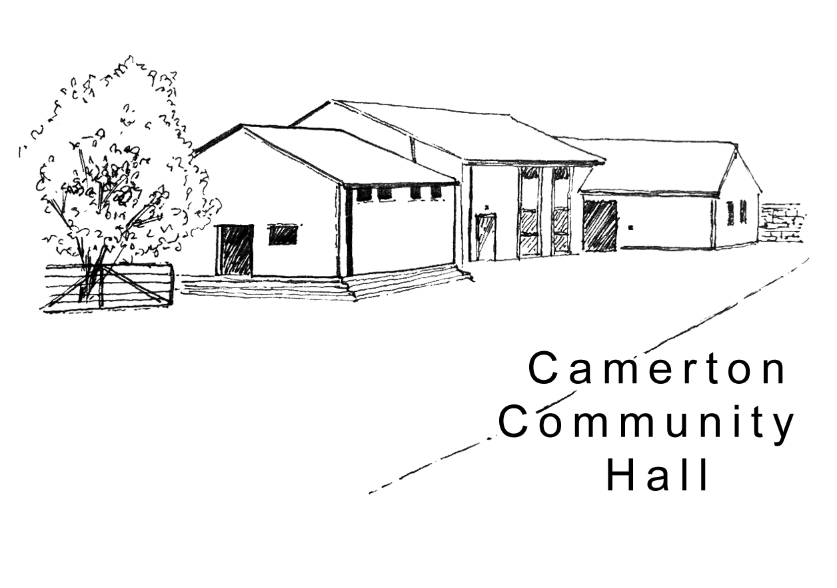

Camerton Community Hall
Registered Charity No. 308263
Wedding Weekend Package – Hall Hire Contract 2024/25

1. DATE/S REQUIRED
Hire  Start Date  From 12 noon  (Additional hours charged at hourly rate) | Hire  End Date  Until 12 noon  (Additional hours charged at hourly rate) | Celebration Bars - Resident Bar Service  No outside bars/Corkage = £2/Bottle  Wine/Drinks Packages available  NB: Specialist alcohol experience (Gin Bar etc.) must provide copy of their Licence |  | No of Guests Attending
 |  | From: | To:

2. HIRER'S DETAILS
Hirer/Name of overall Responsible Person
Home Address
Home Telephone No.
Mobile No.
Email Address
(We ask for email address to enable direct communication with you regarding your booking. We will not share/make public your personal details).
NOTE: Please advise separately if you will not be present for the whole booking, giving a further responsible person’s contact details.

3. HIRE CHARGE
Facilities/Period of Hire | Hire Cost
Access to Hall only between these hours (NO OVERNIGHT STAYS):  Friday,12 noon-11pm – Saturday, 8am-12 midnight – Sunday, 8am-12 noon  (Includes use of oven, crockery/cutlery, dishwasher etc.) | £950 - reviewed annually
Damage/Misuse/Cleaning Deposit | £400 / £800 if camping is required
Camping - Payable in advance by guests (STRICTLY NO DOGS allowed) | See separate form  to be completed by each Unit

4. PAYMENTS DUE Hall Use
Wedding Package Hire Cost |  | £ 950.00
Additional Hours Required @ £15.00 per hour: | No. of hours:
Total Cost of Booking
- 50% of Total Cost PAYABLE TO CONFIRM BOOKING

- FINAL BALANCE Payable 6 weeks PRIOR to the date of Hire

Payment to be made by: BACS (Preferred) [ ] Cheque [ ] CASH [ ]

- 50% Deposit Payment due with completed booking contract to confirm booking (non-returnable)
- BACS to Nat West Bank, Sort Code: 60-14-24 Account Number: 32474628
- Or by Cheque made Payable to: Camerton Community Hall and sent to address below
- Use Payment Reference - Hirer’s name & date of hire (e.g., JSmith 030617)

2.

5. DAMAGE/MISUSE/CLEANING DEPOSIT (DMCD)

BACS details for a different account for Deposits only, will be sent to you when due, 6 weeks prior.

- Damage/Misuse/Cleaning Deposit (DMCD)  OR: If camping required by guests included  Payable 6 weeks PRIOR to actual date of hire as a separate payment | £400  £800
Damage Deposit/Misuse Bond will be returned within 10 working days of hire (subject to compliance with T&Cs)

6. INSURANCE
It is advisable to have your own insurance cover.

7. SAFEGUARDING POLICY
Camerton Community Hall is committed to safeguarding and promoting the welfare of children, young people and vulnerable adults and expects all hirers, trustees, members and volunteers to share this commitment.

DECLARATION
I confirm that I am over 18 and that I have read, understood and agree to observe and abide by the Terms and Conditions of Hire and will be personally responsible for the safe conduct of this event and the activities that take place during the period of hire. I have appropriate insurance and first aid cover (if required) and accept Camerton Community Hall’s commitment to the safeguarding of vulnerable groups:

I note that all activities MUST stop at midnight to allow for clearing up/dispersal of guests to comply with the hall’s Licensing Agreement and prevent disturbance of neighbours.

Signed by Hirer: ........................................................... Date: ......................................................

Print Name: ..................................................................

TO SECURE BOOKING YOU WILL NEED TO:

- Complete Booking Form
- Pay deposit of 50% of Booking Charge by BACS/Cheque (email Treasurer to confirm you have paid)
- Read and sign a copy of the Terms and Conditions

Please return Booking Form with Hire Payments, if cheques, to:

Maggie Hutton, CCHT, Long Acre, Durcott Lane, Camerton BA2 0QE, cchtreasurer@outlook.com

You will receive confirmation of booking by email as soon as all paperwork and initial payments have been received.

Thank you.
We hope you enjoy using our facilities and have a successful event

Camerton Community Hall, Meadgate, Camerton, Bath BA2 0NL
Registered Charity No. 308263
www.camertoncommunityhall.co.uk
January 2023

Appendix

Camerton Community Hall

The Camerton Community Hall Management Committee manages the Hall and its grounds. Hirers must look after the facilities, collect and leave keys as required and leave the venue in a clean and tidy condition.

Failure to comply with any of your contractual responsibilities listed below could result in some/all of your Damage Misuse Bond being withheld.

HIRERS RESPONSIBLITIES - 10 Essentials

- Maximum number of people must not exceed 200. The Hirer is responsible for the Hall during the hire period and must be present and responsible for the event at all times.

- Insuring his/her own activities. Events involving young people under the age of 21 must be supervised by a minimum of three adults aged 21 and over.

- It is a residential area – please keep noise down and to an absolute minimum outside the hall, especially late at night including in-car music, shouting, screaming and rowdy behaviour. YOU will be held responsible for your guests conduct on or around the hall.

- No alcohol to be personally brought onto the premises where a bar under licence has been booked.

- You must familiarise yourself with Fire Exits and foam/dry fire extinguishers. Fire Exits/corridors must not be obstructed at any time. Battery operated candles/tea lights ONLY to be used.

- NO DOGS ALLOWED – on hall property including the field, car park and copse areas, unless authorised.

- No pins, staples, adhesive etc. to be attached to the fabric of the hall. Blu-Tack can be used and hooks are provided. No extra lighting, extensions, heating appliances or other electrical equipment must be used without prior consent of the Committee.

- As stipulated by the local authority, A NOISE LIMITER governing device will cut out electric in the event of extreme levels of sound. Please bring TO THE ATTENTION OF the Band, DJ or entertainment. Music must stop at midnight.

- The Hall, kitchen and bar areas to be left in a clean and clear state. ONLY non-abrasive cleaning materials to be used. The hirer must NOT attempt repair work.

- You must bring your own black bin bags and ALL rubbish and recycling MUST be taken away from the hall premises/grounds on leaving so as not to affect return of your full Damage Deposit/Misuse/Cleaning Bond. The Hirer is responsible for vacating everyone and everything from the Hall by the time stated, ensuring all equipment is turned off and doors/windows locked. Please remove all rubbish and effects.

Full Responsibilities are detailed in the Hall’s Terms and Conditions of Hire
to be seen at www.camertoncommunityhall.co.uk

February 2022

