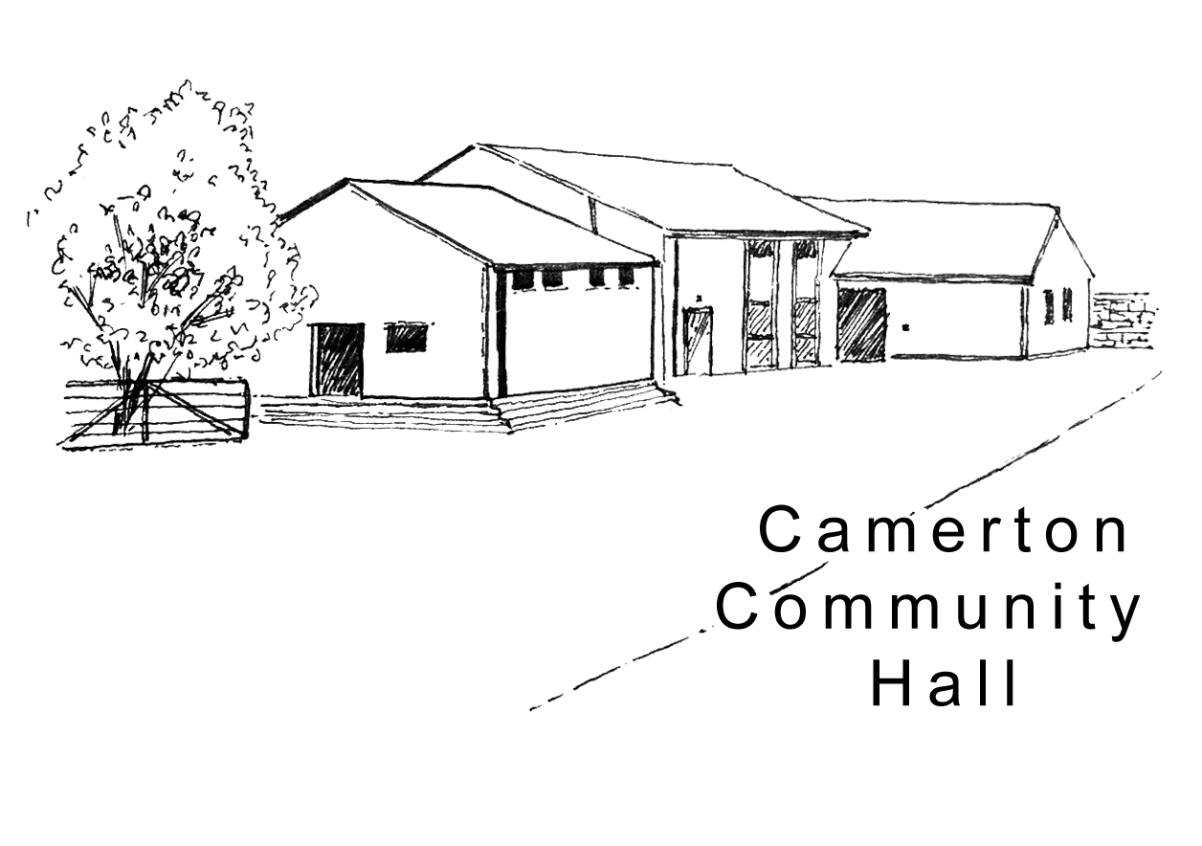

Camerton Community Hall
Registered Charity No. 308263
Single Use Hire Contract 2026/27

To secure your booking you must complete and return booking form and pay 50% deposit.

- DAY / DATE / TIMES OF HIRE REQUIRED

Day | Date Required | Hall Hire Period  (To include setting up & clearing) |  | Hours | Time of Resident Bar Service Required @ £50.00
Day | Date Required | Start: | End: | Total | From: | To:

- PURPOSE OF HIRE (please include age if a children’s birthday party)
Approx. No. attending (190 max)

- HIRER'S DETAILS

Organisation (if applicable): ..................................................................................................................................

Hirer/Name of overall Responsible Person present at end of hire: ..............................................................................

Address: ....................................................................................................................................Post Code …………...

Mobile: .....................................................Work: …………….…......………Email: ........................................................
(We ask for your email address to enable communication directly with you. We do not share or make public your personal details)

- HALL HIRE CHARGES

Facilities/ and Period of Hire | Number Required | Hire Charge | Sub Total £
Hourly Rate (Field use is separate charge on application)  (Except, Fri 6pm-12 midnight + Sat as below) |  | £15.00
Fri 6pm-12 midnight |  | £100
Saturday all day/evening, 8am-midnight  Saturday evening, 6pm-midnight |  | £300.00  £175.00
Gas/Electric Ovens, per 4 hour session.  Please note there is no catering equipment |  | £25.00
Resident Bar Service |  | £50.00
Having a Bouncy Castle (not provided) |  | £10.00
Electric Hook Up for commercial vehicles (not cars) |  | £20.00

*Enquire for discount available to Friends of Hall and local residents.
To qualify for the 50% discount a “Friend” needs to have completed 20 hours of volunteering prior to the booking date.
The Booking is only for the “Friend” and does not apply to family members or friends of “Friends”.

5. INITIAL PAYMENTS
Total Cost |  | £
Initial 50% of Total Cost, non-Returnable, payable immediately to secure |  | £
BACS payment (preferred) payable to: Camerton Community Hall (Somerset)
Sort Code: 60-14-24
Account Number: 32474628
Payment Reference – Put Hirer’s name & date of event (e.g. JSmith030617). Please email to advise payment.

Cheque made payable to ‘Camerton Community Hall’ and sent to: Camerton Community Hall Treasurer, Long Acre, Durcott Lane, Camerton, BA2 0QE.
(Confirmation will be emailed from camertoncommunityhalltreasurer@outlook.com as soon as the Booking Form and initial payments (50% deposit + DMCD) have been received).

Final 50% of Total Cost, due 6 weeks prior to date of hire | £

6. DAMAGE/MISUSE/CLEANING DEPOSIT
Damage/Misuse/Cleaning Deposit (DMCD): A request for this payment and details of our separate ‘Deposits Only’ bank account, will be emailed to you 6 weeks prior to event. This will be refunded with 10 working days following your event, subject to all T&Cs being met.  - Hourly Bookings per event - £50  - Saturday and Evening Events - £150  - 21st Parties (strictly no 18th parties allowed) - £300  - Camping/Other Special Events – Price on Application | £

7. SAFEGUARDING
Camerton Community Hall is committed to safeguarding and promoting the welfare of children, young people and vulnerable adults and expect all hirers, trustees, members and volunteers to share this commitment.

DECLARATION
I confirm that I am over 18 and that I have read, understood and agree to observe and abide by the Terms & Conditions of Hire (www.camertoncommunityhall.co.uk/rentals) and the attached Appendix –
Hirer’s Responsibilities - 10 Essentials:

I will be personally responsible for the safe conduct of this event and the activities that take place in association with the booking/period of hire:

I accept Camerton Community Hall’s commitment to the safeguarding of vulnerable groups:

Signed by Hirer: ............................................

Print: …………………………………………... Date: .............................................

Thank you. We hope you enjoy using our facilities and have a successful event

Camerton Community Hall, Meadgate, Camerton, Bath BA2 0NL
Registered Charity No. 308263
www.camertoncommunityhall.co.uk

Appendix
Please retain and also inform all those helping close the Hall down.

Camerton Community Hall

The Camerton Community Hall Management Committee manages the Hall and its grounds. Hirers must look after the facilities, collect and leave keys as required and leave the venue in a clean and tidy condition.

Failure to comply with any of your contractual responsibilities listed below could result in some/all of your Damage Misuse Bond being withheld.

HIRERS RESPONSIBLITIES - 10 Essentials

- Maximum number of people must not exceed 190. The Hirer is responsible for the Hall during the hire period and must be present and responsible for the event at all times.

- Insuring his/her own activities. Events involving young people under the age of 21 must be supervised by a minimum of three adults aged 21 and over.

- It is a residential area – please keep noise down and to an absolute minimum outside the hall, especially late at night including in-car music, shouting, screaming and rowdy behaviour. Keep all doors closed where possible. The Hirer will be held responsible for your guests conduct in or around the hall.

- No alcohol to be personally brought onto the premises where a bar under licence has been booked.

- You must familiarise yourself with Fire Exits and foam/dry fire extinguishers.
Fire Exits/corridors must not be obstructed at any time.
ONLY Battery-operated candles/tea lights to be used.

- NO DOGS ALLOWED – on hall property including the field, car park and copse areas, unless authorised.

- No pins, staples, adhesive etc. to be attached to the fabric of the hall. Blu-Tack can be used and hooks are provided. The Hirer must not attempt any repair work. No extra lighting, extensions, heating appliances or other electrical equipment must be used without prior consent of the Committee.

- As stipulated by the local authority, A NOISE LIMITER governing device will cut out electric in the event of extreme levels of sound. Music must stop by midnight.
Please bring TO THE ATTENTION OF the Band, DJ or entertainment.

- The Hirer must bring their own black bin bags and washing up sundries. ONLY non-abrasive cleaning materials to be used. ALL rubbish and recycling MUST be taken away from the hall premises/grounds on leaving so as not to affect return of your full Damage Deposit/Misuse/Cleaning Bond.

- The Hall, kitchen, bar and entrance areas to be left in a clean and clear state. The Hirer is responsible for vacating everyone and everything from the Hall by the time stated, ensuring all equipment is turned off and doors/windows locked. Please remove all rubbish and effects.

Full Responsibilities are detailed in the Hall’s Terms and Conditions of Hire
to be seen at www.camertoncommunityhall.co.uk

