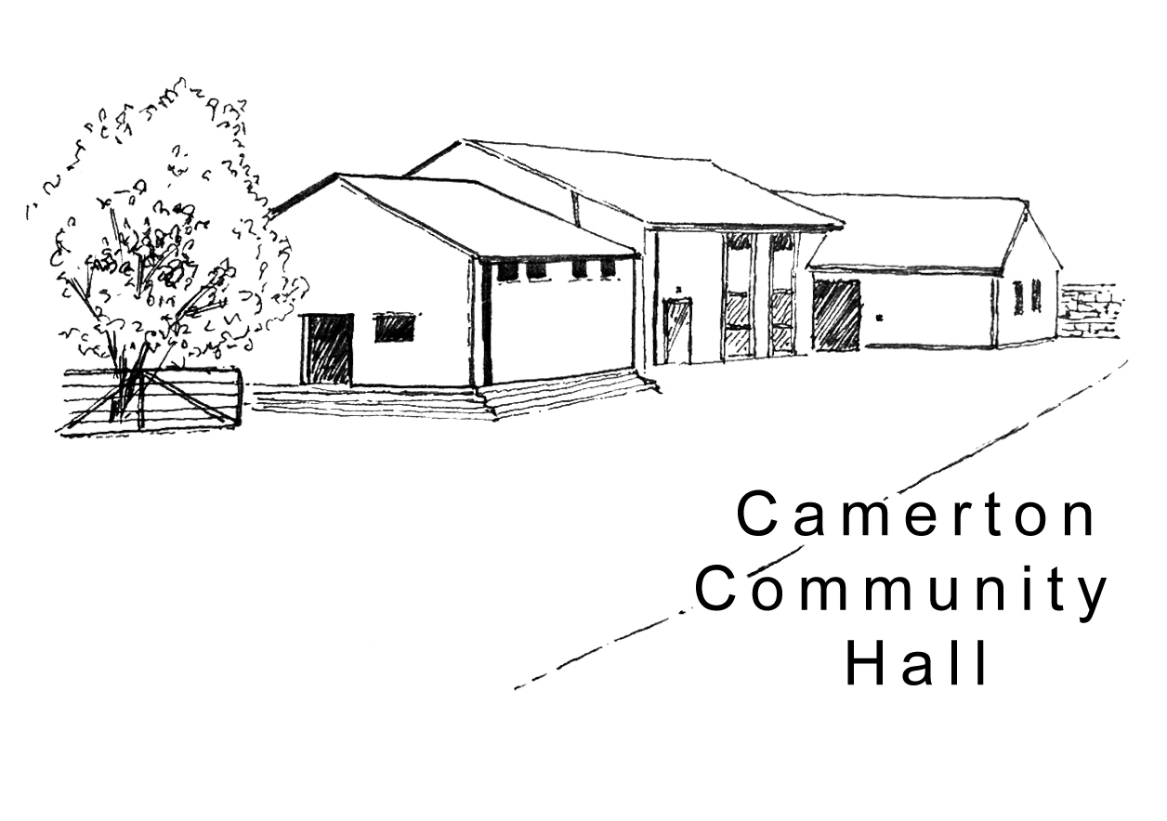
Camerton Community Hall
Registered Charity No. 308263

Organised Rally - Booking Form 2024/25
Designed for individual guests to complete and Organiser/Individual to return DIRECT to the Treasurer with full payment.

1. EVENT/HIRER DETAILS
Name of Organisation
Name of Event: |  |  | Approx. no. of units
Lead Person
Address
Landline |  | Mobile
Email address

2. FIELD USE
Date of Arrival | Date of Departure

3. HALL HIRE – dates and times required
Day of Week | Date | Start Time  (to include setting up) | Finish Time  (to include clearing up)

4. HIRE CHARGE (Reviewed Annually):
Booking Charge | Cost | No. of Hours Required | Total
Single Pitch | £10 per unit per night
Hall Hire Sunday-Friday 6pm | £15 per hour
Saturday all day 8am-12 midnight | £300
Saturday 6pm-12 midnight | £175

4. PAYMENT
- To secure booking, 50% deposit required on booking in advance; balance to be paid 6 weeks before event.
- Please pay by BACS payment to Camerton Community Hall (Somerset), Sort Code: 60-14-24, Account Number: 32474628, Ref - (date of event)
- Or by Cheque/s payable to Camerton Community Hall and posted to address below.

5. SAFEGUARDING
Camerton Community Hall is committed to safeguarding and promoting the welfare of children, young people and vulnerable adults and expects all hirers, trustees, members and volunteers to share this commitment.

6. NO DOGS: on hall property including the recreation field, car park and Colliers Copse areas, unless authorised.

7. DECLARATION
I confirm that I am over 18 and that I have read, understood and agree to observe and abide by the Code of Conduct with the Terms and Conditions of Hire of the Hall and Recreation Field (www.camertoncommunityhall.co.uk/rentals) and will be personally responsible for the safe conduct of my party and the activities that take place during our stay.

Signed: ...................................................... Print Name: ………………….…………………………..……… Date: ......................................

Return to: Maggie Hutton, Treasurer, Longacre, Durcott Lane, Camerton, BA2 0QE, cchtreasurer@outlook.com

Thank you. We hope you enjoy using our facilities and have a great stay
Camerton Community Hall, Meadgate, Camerton, BA2 0NL
www.camertoncommunityhall.co.uk
January 2023

